**Project Report Template**

**TITLE: JOB APPLICATION TRACKING SYSTEM**

**1. INTRODUCTION**

**1.1.Overview:**

An applicant tracking system (ATS) is software for recruiters and employers to track candidates throughout the recruiting and hiring process.

An ATS is a type of software application that handles the recruitment process, namely by sorting through thousands of resumes, to determine which ones are the best fit for the positions for which they were submitted.

An ATS compliant resume is **one that can be easily scanned and interpreted by an applicant tracking system (ATS)**. This means that your resume should be formatted clearly, with relevant keywords included.

**1.2.Purpose:**

An ATS creates opportunities to automate manual processes, increase visibility into the hiring cycle for the entire recruiting team, and increase opportunities for communication throughout the candidate journey.

78% of recruiters using an ATS report that it has improved the quality of the candidates they hire.

**2.Problem Definition & Design Thinking**

**2.1 Empathy Map**

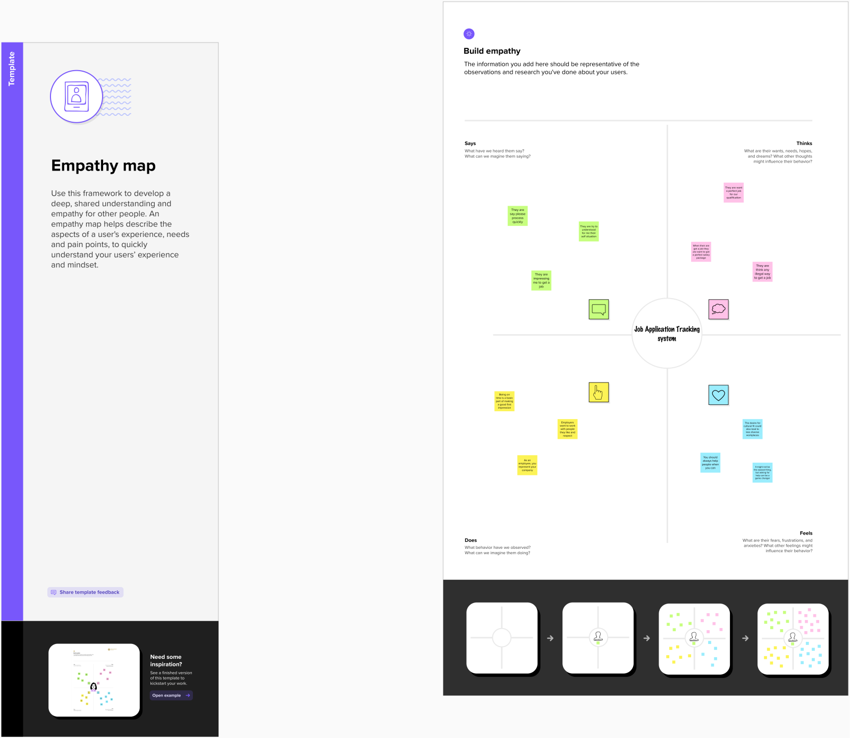

**2.2 Ideation & Brainstorming Map**

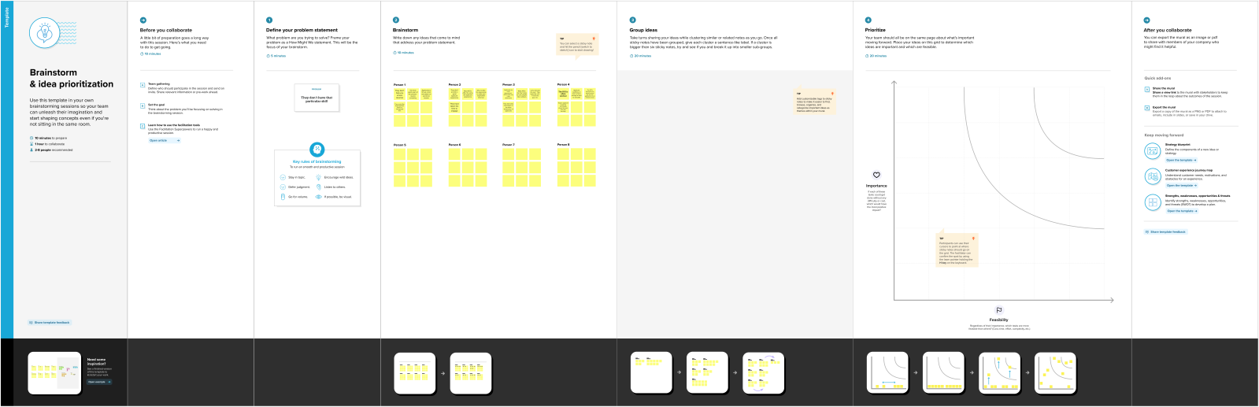

**3. RESULT**

**3.1 Data Model:**

|  |  |
| --- | --- |
| **Object Name** | **Field in the Object** |
| **JOB** | |  |  | | --- | --- | | **Field Label** | **Data Type** | | Job Name | Text(80) | | Recruiter | Master Detail | | Location | Text(30) | | Description | Text area(255) | |
| **CANDIDATE** | |  |  | | --- | --- | | **Field Label** | **Data Type** | | Canditate Name | Text | |
| **RECRUITER** | |  |  | | --- | --- | | **Field Label** | **Data Type** | | Rec Name | Text | | Job Title | Text | |
| **JOB APPLICATION OBJECT** | |  |  | | --- | --- | | **Field Label** | **Data Type** | | Job Application Name | Text | |

**3.2 Activity & Screenshot**

**Objects Creation :**

**Job :**

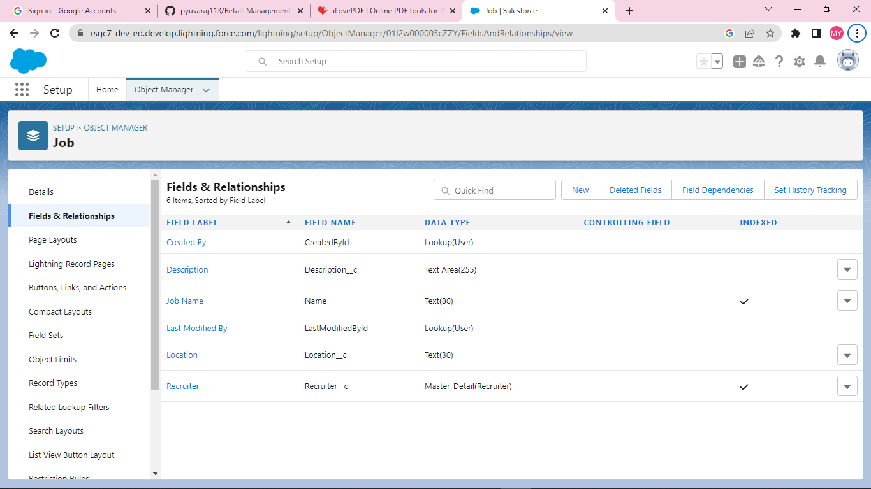

**Candidate :**

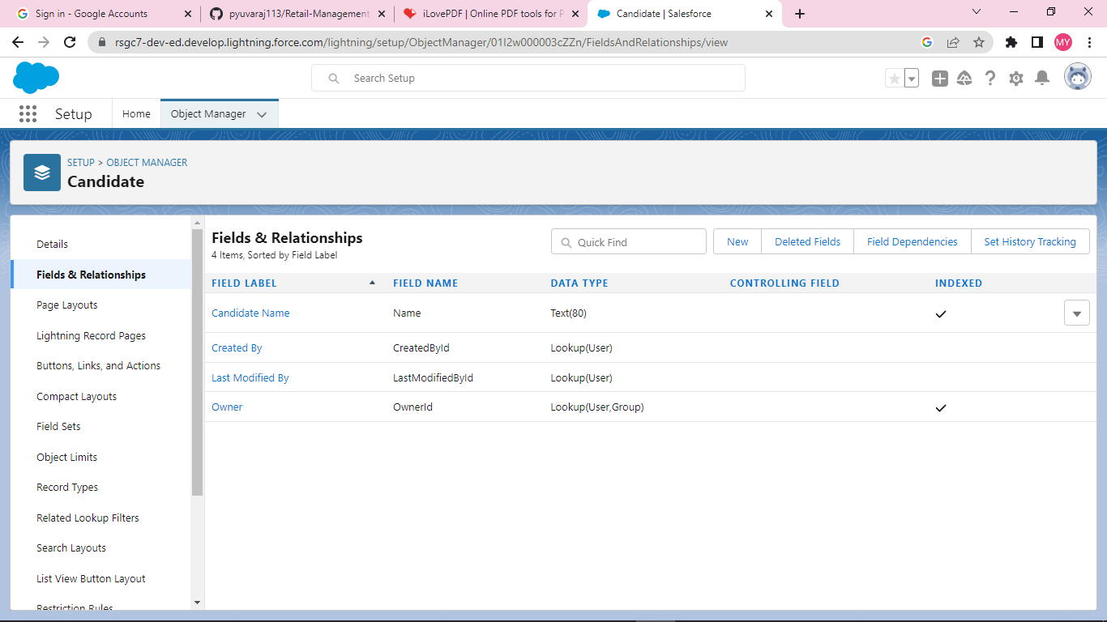

**Job Application Object :**

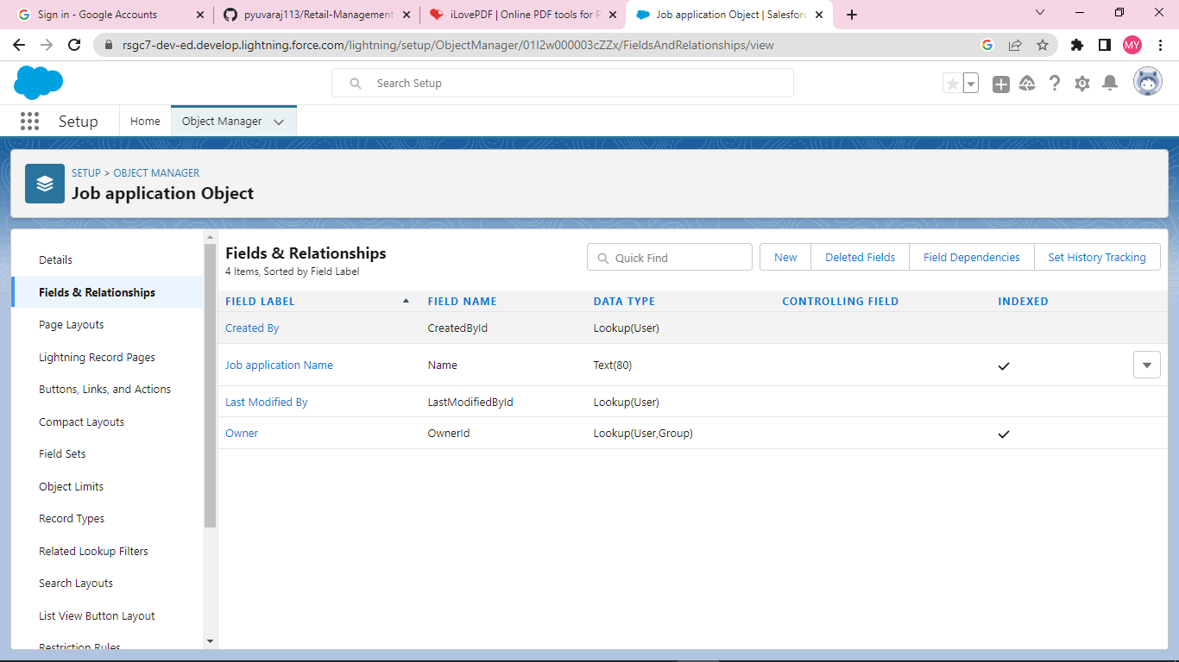

**Recruiter :**

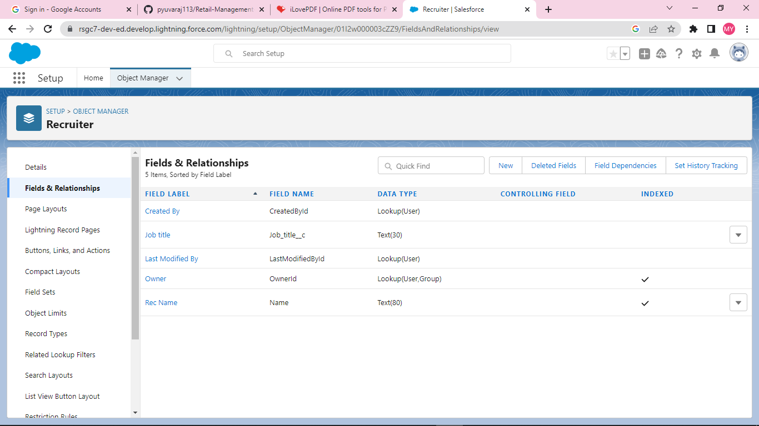

**4. Trailhead Profile Public URL**

Team Lead – Visalam R - <https://trailblazer.me/id/vviram611>

Team Member 1 – Sangeetha A- <https://trailblazer.me/id/sangeetha2003>

Team Member 2 – Virthiha P- <https://trailblazer.me/id/virthiha17>

Team Member3 – Madhavan P- <https://trailblazer.me/id/mmadhaw1>

**5. ADVANTAGES & DISADVANTAGE**

Advantages:

* Saves Time for Value Added Work. ...
* Flexible System for Both Employer & the Agency
* Better Overview of Applications. ...
* Easy Job Posting. ...
* Improved Cost-per-Hire. ...
* Improved Quality of Hire. ...
* Improved Inter-Departmental Communication. ...
* Faster & Better Decisions.

Disadvantages:

* A Disadvantage of ATS is missing qualified applicants due to wrong keyword selection.
* Automatic elimination of resumes that software cannot recognize and interpret is another drawback of ATS.
* An Applicant Tracking System Disadvantage is that they are open to manipulation.

**6. APPLICATIONS:**

An applicant tracking system (ATS) is software for recruiters and employers **to track candidates throughout the recruiting and hiring process**.

**7. CONCLUSION:**

Applicant Tracking System for recruiters is a very effective hiring solution that most of the successful recruiters utilize.

Because without it, there is a good chance that your process of moving applicants through different stages can become very difficult.

**8. FUTURE SCOPES:**

According to a recently released survey report, the majority of staffing firms worldwide will opt for an Applicant Tracking System by the end of 2020 to improve the overall talent acquisition efficacy, in this scope the future of ATS definitely looks bright.